- What dangers may you face in the office in regard to office safety? (List 3)

- How many injuries occur annually (per year) in the workplace?

- What are some common office injuries?

- What is considered to be poor design or poor housekeeping (dangers) in the office? (3)

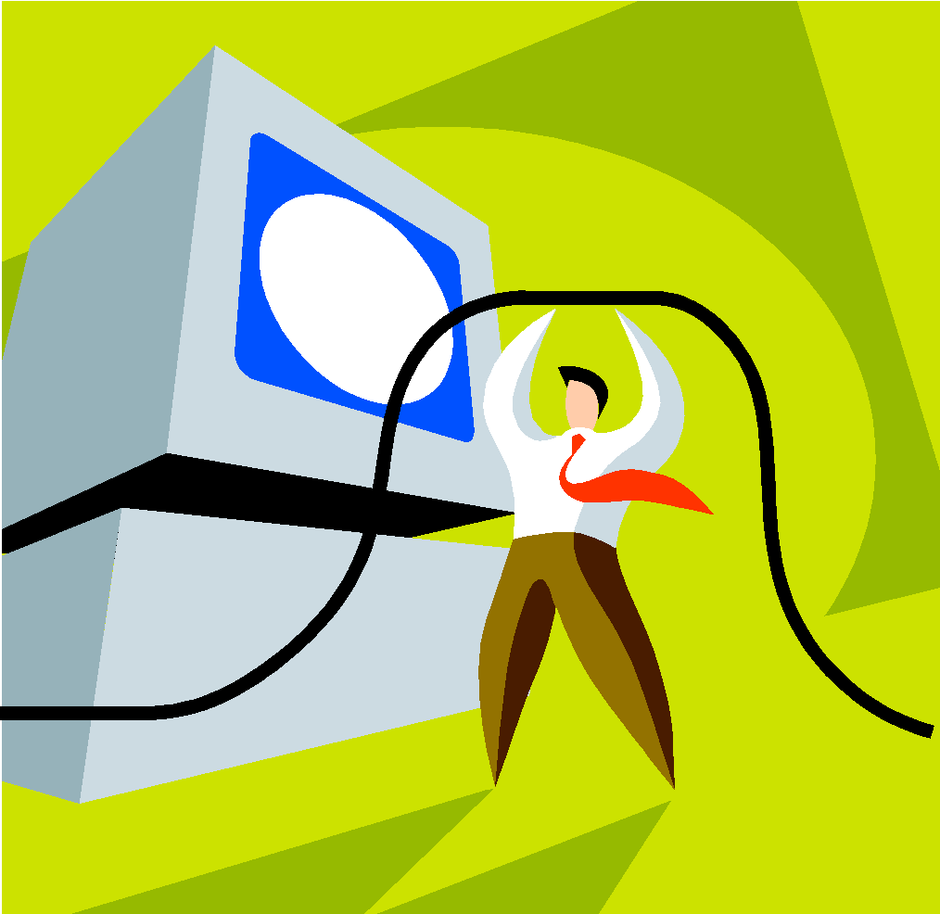
- How much distance should be maintained between desks?
- What should be done with cords?
- What should be done with office machines?

- Do not _____________ exits!
- How many exits should be provided?
- Employees must be aware of ___________ and trained in ____________ procedures.
- What forms of combustible materials exist? (3)

- Fire _________ and alarms must be conspicuously _________ and accessible.
- Improper _________ of materials can cause ____________ disorders such as sprains, strains, and inflamed joints.

- Office materials that are improperly __________ can lead to hazards such as objects __________ on workers, poor visibility, and fires.

- Explain how office furniture can contribute to injuries in the workplace.

- Don’t _________ back in an office chair with your feet up.
- What two rules must you follow about filing cabinets?

- Keep desk drawers ___________ when not in use.
- Equipment must be properly ____________ to prevent shock injuries.
- Cords should not be ____________ over nails, hooks, or other sharp objects.
- What two hazards may result from using a copy machine?

- Avoid wearing ________ or ___________ clothing or accessories around machinery with moving parts.
- Paper cutters - Keep blade _________ when not in use.
- A ___________ should be provided and fingers kept clear.
- What health concerns do computer monitors involve? (List two)

- Proper ergonomic design should be tailored to prevent discomfort. List three factors to consider:

- Sources of air pollution in the office include both _______________ (e.g.,mold spores) and ______________ (e.g., cleaning fluids).

- Lighting problems in the office include (list four)

- Noise sources in the office include:

- What did you learn new today?

